Omer Mehboob
24165869
Option B
Cloud AI/ MLOps

Architecture/Design:
I selected Flask for this microservice because it is a lightweight WSGI web application framework. For a single-endpoint inference API, Flask provides the necessary functionality (routing and request handling) with minimal boilerplate code.
While alternatives like FastAPI offer asynchronous capabilities, Flask's synchronous execution model is perfectly sufficient for this CPU-bound task (loading a serialized model and computing a prediction). Its simplicity allows for rapid development and easy integration with the scikit-learn ecosystem.
The project follows a standard MLOps directory structure to separate the training phase from the serving phase:
- train_model.py (The Builder): An offline script that preprocesses data, trains the Random Forest classifier, and serializes the model state.
- model.pkl (The Artifact): The binary file containing the trained model logic. This acts as the bridge between the training environment and the production container.
- app.py (The Service): The inference engine. It loads the artifact (model.pkl) into memory upon startup and exposes the /predict API endpoint to handle incoming client requests.
- Dockerfile (The Packaging): Defines the immutable environment, ensuring that the Operating System, dependencies (scikit-learn), and application code are bundled together for consistent deployment.

Step 1: The Model Artifact (Serialization)
Code:
import joblib
from sklearn.datasets import load_iris
from sklearn.ensemble import RandomForestClassifier
iris = load_iris()
X, y = iris.data, iris.target
clf = RandomForestClassifier()
clf.fit(X, y)
joblib.dump(clf, 'model.pkl')
print("Model trained and saved as model.pkl")
Explanation:
import joblib: This is the "Save Game" tool. Python objects normally die when the script ends. joblib lets us save the AI's brain to the hard drive.
sklearn (Scikit-Learn): this is the machine learning library. I used two things from it:
- load_iris: A built-in dataset.
- RandomForestClassifier: The actual "brain" algorithm.
iris = load_iris(): We open the "textbook." This dataset contains 150 examples of real flowers.
X:This variable holds the measurements (Petal Length, Petal Width, etc.).
y :This variable holds the Species ID (0 = Setosa, 1 = Versicolor, 2 = Virginica).
clf = ...: I created an empty, untrained brain. clf stands for "Classifier." At this exact moment, it knows nothing.
clf.fit(X, y): This is the most important line.
- The .fit() command tells the AI: "Look at these measurements (X) and these species labels (y). Figure out the mathematical rules that connect them."
joblib.dump(...): This takes the trained clf object (which is currently just in the RAM) and writes it to a physical file named model.pkl.

Execution/Verification:
*Installing the library
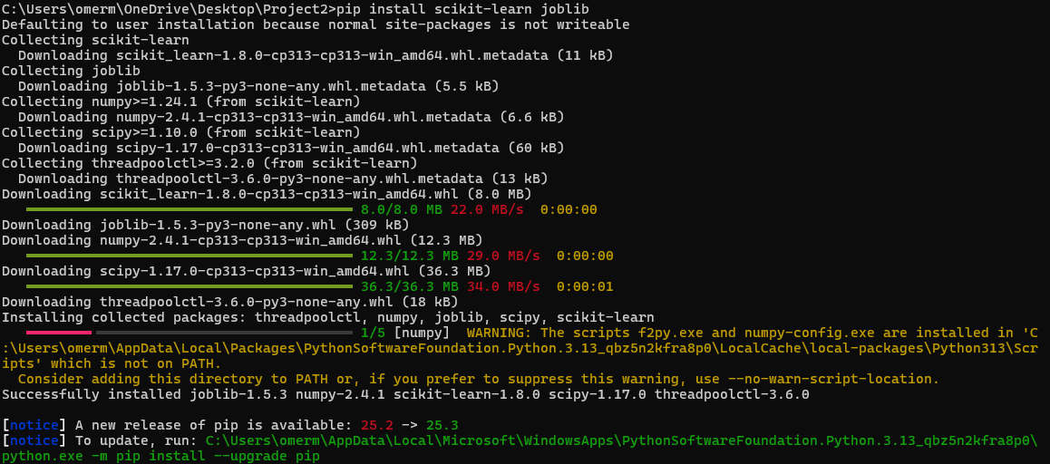
*Running the python file

Step 2: The API Server (Inference Interface)
Code:
from flask import Flask, request, jsonify
import joblib
import numpy as np

app = Flask(__name__)
model = joblib.load('model.pkl')
class_names = ['setosa', 'versicolor', 'virginica']

@app.route('/predict', methods=['POST'])
def predict():
data = request.get_json()
features = np.array([[
data['sepal_length'],
data['sepal_width'],
data['petal_length'],
data['petal_width']
]])
prediction_id = model.predict(features)[0]
prediction_name = class_names[prediction_id]
return jsonify({
'prediction': prediction_name,
'class_id': int(prediction_id)
})
if __name__ == '__main__':
app.run(host='0.0.0.0', port=5000)
Explanation:
model = joblib.load('model.pkl'): This satisfies the requirement to "load the model." I do it outside the function so it loads only once when the server starts, rather than reloading it for every single user request which is slow.
@app.route('/predict', methods=['POST']): I use POST because we are sending data to the server. (GET is for downloading pages; POST is for submitting forms/data).
data = request.get_json():The user sends a JSON packet with measurements
features = np.array(...): The model is picky. It was trained on mathematical arrays, so we must convert the incoming JSON text into a numpy array of numbers before asking for a prediction.
return jsonify(...): APIs speak JSON. Converting the Python answer back into JSON format so the computer can understand it.

Step 3: Containerization (Docker)
Code:
FROM python:3.9-slim
WORKDIR /app
RUN pip install flask scikit-learn joblib numpy
COPY . .
EXPOSE 5000
CMD ["python", "app.py"]
Explanation:
I utilized a Dockerfile to contain the machine learning environment. I selected python:3.9-slim as the base image to minimize the container's footprint.
A critical step was the RUN pip install command, which installs scikit-learn, joblib, and numpy. This ensures the container environment exactly matches the local environment where the model was trained; without these specific libraries, the serialized model file would fail to load.
Finally, I used the COPY . . command to transfer not just the application code (app.py), but importantly, the trained model artifact (model.pkl) into the image. This makes the container fully self-contained, capable of performing inference without needing access to external storage.
Execution/Verification:
*Creating the container
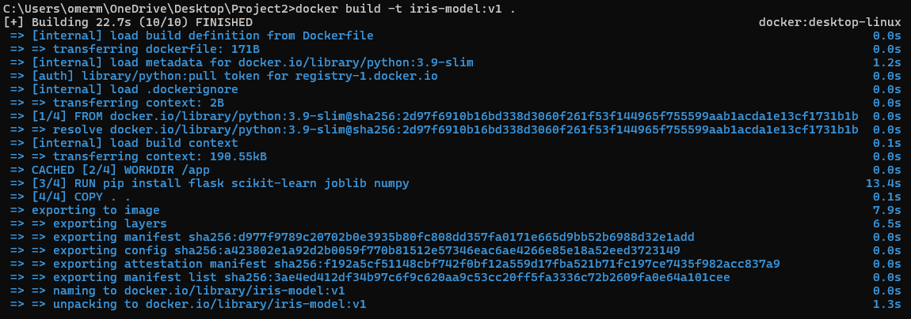
*Running the container/ checking its running
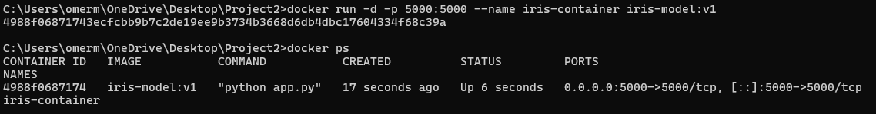
*Testing

Analysis:
Why is it better to deploy this model inside a Docker container rather than just running python app.py directly on a cloud Virtual Machine (VM)? Focus on “Dependency Hell” or “Environment Consistency.”
Docker vs. Virtual Machines For this Machine Learning application, Docker containers are superior to Virtual Machines (VMs) due to portability and efficiency.
- Isolation without Overhead: A VM would require a full guest Operating System (like installing a whole new Windows or Linux OS) just to run this small Python script. This would waste gigabytes of RAM and storage. Docker shares the host OS kernel, meaning the container only takes up a few hundred megabytes and starts in seconds rather than minutes.
- Dependency Management: The "It works on my machine" problem is solved. In my Dockerfile, I explicitly pinned the versions of scikit-learn and joblib. This ensures that the model—which relies on specific library versions to deserialize the .pkl file—will run exactly the same way on a cloud server as it does on my local development laptop. A VM might have conflicting system libraries that break the model loading process.
AI Usage:
I used Gemini to help me code in python as I didn’t have too much knowledge on coding in the language. I also used Gemini to assist me in trying to learn and understand what was being outputted and why.

